Name ______________________________ HOMEWORK Nov. 7-11
Put your initials by each night that your child practiced the following:
____Monday ____Tuesday ____Thursday
*Nightly Homework*
1. Practice saying letter names and sounds.
2. Count numbers 1-25.
3. Practice assigned Sight Word list in red reading folder.
Name the letters and sounds.
Mm Tt Ss Bb Aa Nn
Dd Cc Pp Ii Rr Ff

Monday: Trace the work. Color the box to tell whether it is a noun or a verb. Draw a picture in the box to match the word.
Circle the correct ending sound for each word.
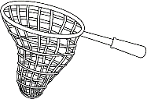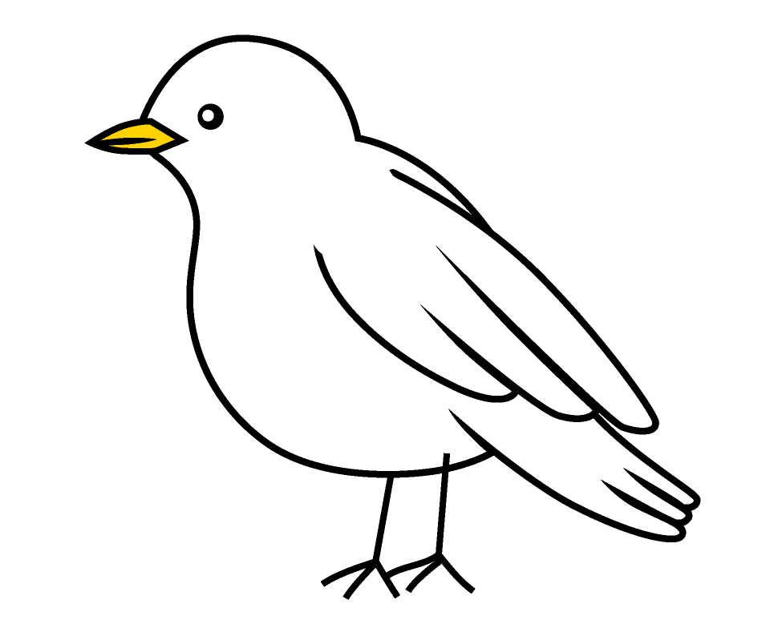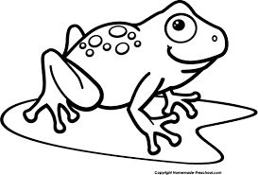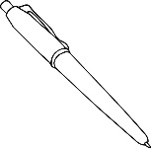
f n t d c n f n g n d p
TUESDAY- Practice writing each spelling word three times.
cat map mat

_______________ _______________ _______________

_______________ _______________ _______________

_______________ _______________ _______________

Read the words. Circle words in the “ip” word family.

tip mad flip rip mad sip bad pad zip

THURSDAY- Add a letter to the beginning of each word to create rhymes. Practice reading the rhyming words.

Sight Words to know
an has it little he ran
she funny did in put blue
me sits with two

Nat and Mac
By Jo Wakaba
“Mac! Mac, can you see me?”
“Nat, sit with me.”
Nat sits with Mac. Mac rips it.
Mac dips it in. Mac pats it.
Mac fits it in a pan.
Mac tips it in.
“Mac, you did it!”

